**Experiment No. – 7**

**Student Name: SUMIT KUMAR UID: 20BCS8226**

**Branch: BE-CSE Section/Group: MM 808 A**

**Semester: 5th Date of Submission: 12-11-2022**

**Subject Name: Competitive coding - I Subject Code: 20CSP-314**

# **Separate the Numbers**

1. **Aim/Overview of the practical:**

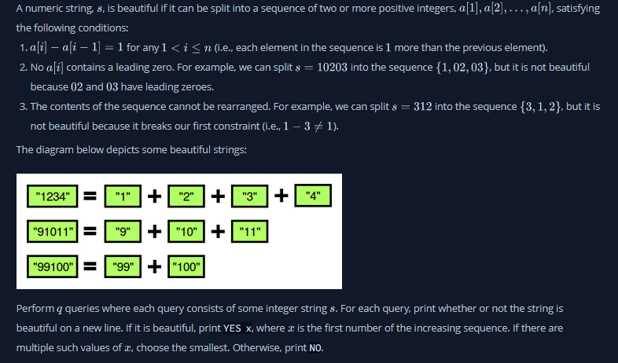

**2. Task to be done/ Which logistics used:**

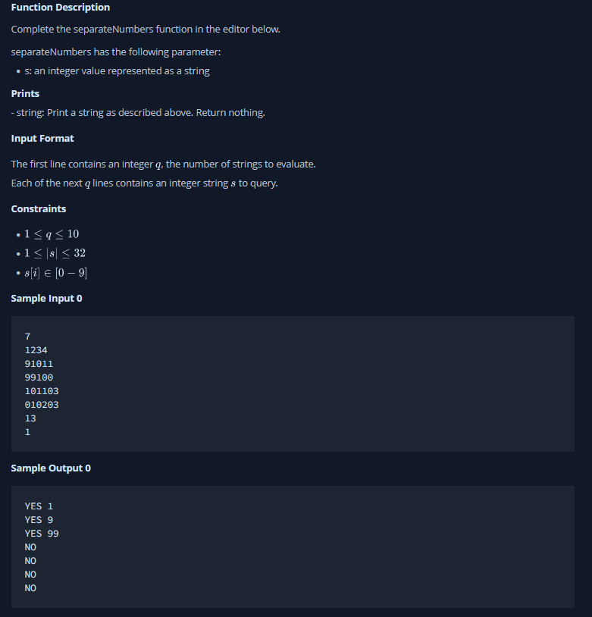

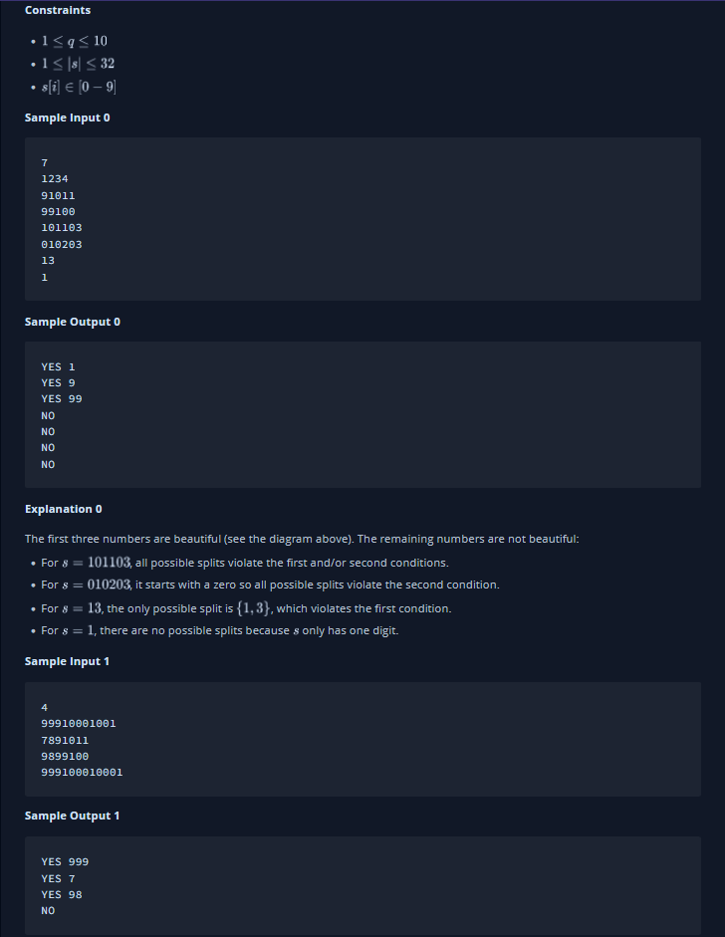

**3. Hardware and Software Requirements (For programming-based labs):**

* Laptop or Desktop
* Hacker-Rank Account

**4. Steps for experiment/practical/Code:**

public static boolean CheckBeautiful(long start,int nd,String s,int len)

    {

        long next=start+1;

        int nxt_size=(String.valueOf(next)).length();

        while((len-nd)>=nxt_size)

        {

            long nxt_num=Long.parseLong(s.substring(nd,nd+nxt_size));

            if(nxt_num==next)

            {

                nd=nd+nxt_size;

                next=nxt_num+1;

                nxt_size=(String.valueOf(next)).length();

            }

            else

                return false;

        }

        if((len-nd)!=0)

            return false;

        else

            return true;

    }

    public static void separateNumbers(String s) {

    // Write your code here

        int len=s.length(),flag=0;

        if(len==1 || s.charAt(0)=='0')  //Handeling base condition.

            System.out.println("NO");

        else

        {

            for(int i=1;i<=(s.length()/2);i++)

            {

                int no_digits=i;    //starting with number of digits.

                long start=Long.parseLong(s.substring(0,no_digits));

                boolean ans=CheckBeautiful(start,no_digits,s,len);

                if(ans==true)

                {

                    System.out.println("YES"+" "+start);

                    flag=1;

                    break;

                }

            }

            if(flag==0)

                System.out.println("NO");

        }

    }

**5. Result/Output/Writing Summary:**

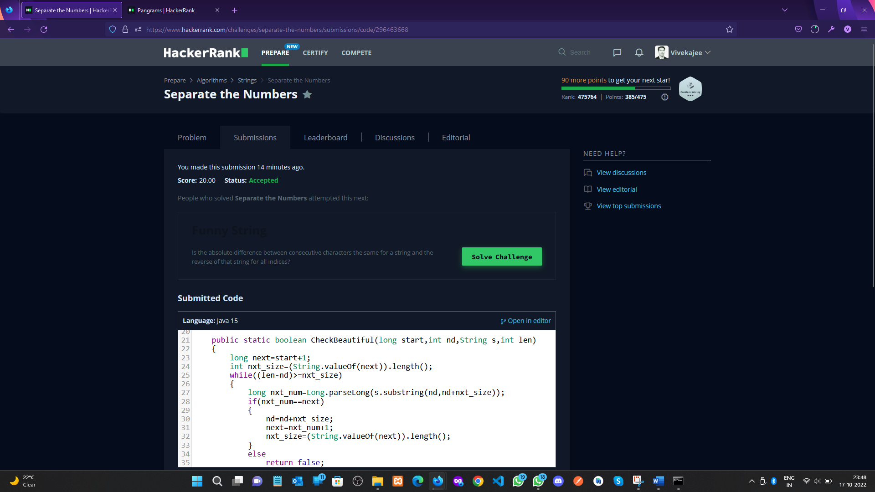 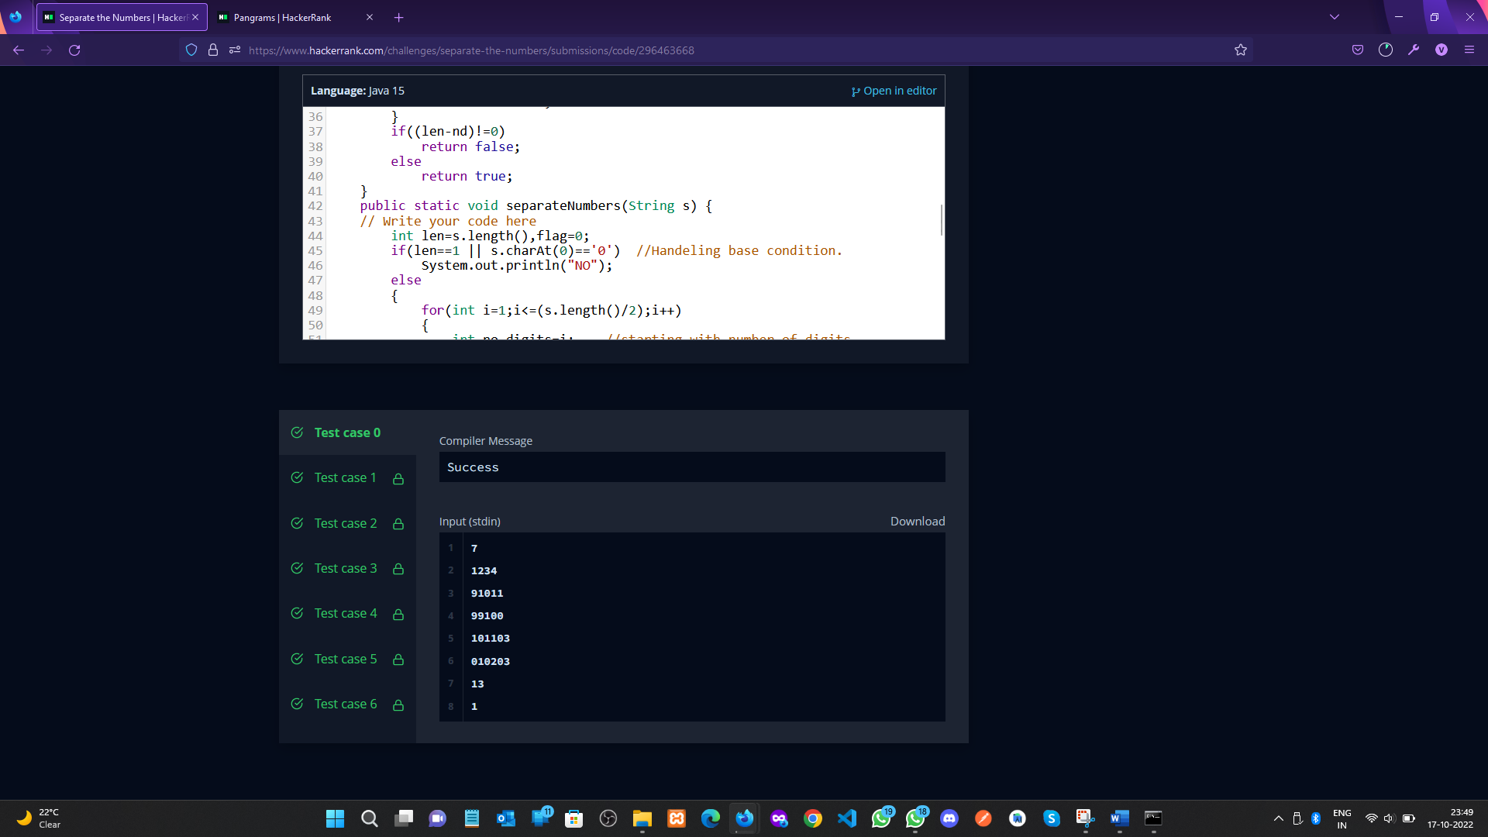

**Pangrams**

1. **Aim/Overview of the practical:**

A pangram is a string that contains every letter of the alphabet. Given a sentence determine whether it is a pangram in the English alphabet. Ignore case. Return either pangram or not pangram as appropriate.

1. **Task to be done/ Which logistics used:**

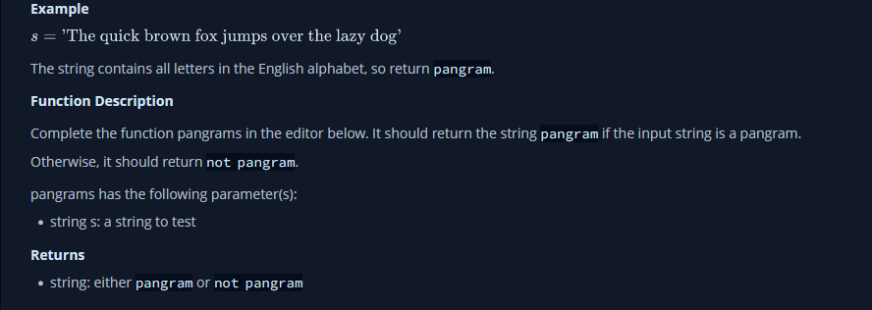

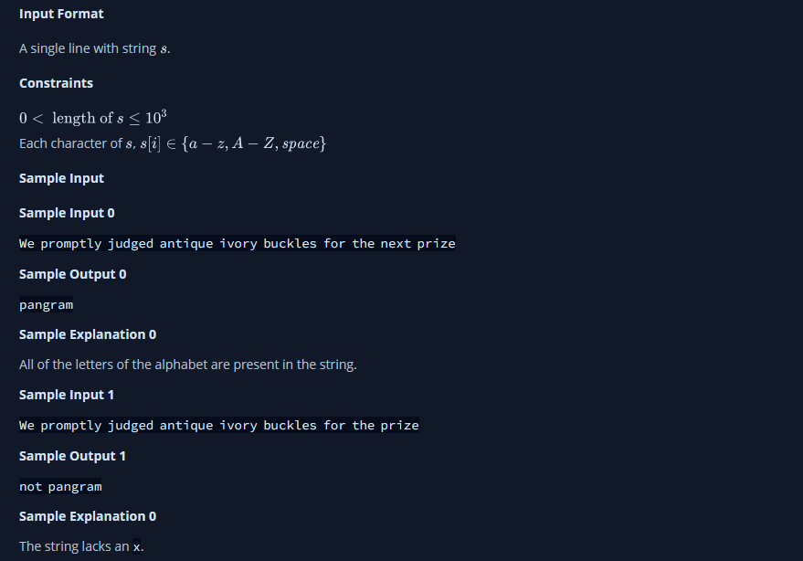

1. **Hardware and Software Requirements (For programming-based labs):**

* Laptop or Desktop
* Hacker-Rank Account

1. **Steps for experiment/practical/Code:**

public static String pangrams(String s) {

boolean[] hash = new boolean[26];

for(char ch:s.toCharArray()) {

if('a'<=ch && ch <= 'z') hash[ch-'a'] = true;

if('A'<=ch && ch <= 'Z') hash[ch-'A'] = true;

}

for(boolean b:hash)

if(!b)

return "not pangram";

return "pangram";

}

1. **Result/Output/Writing Summary:**

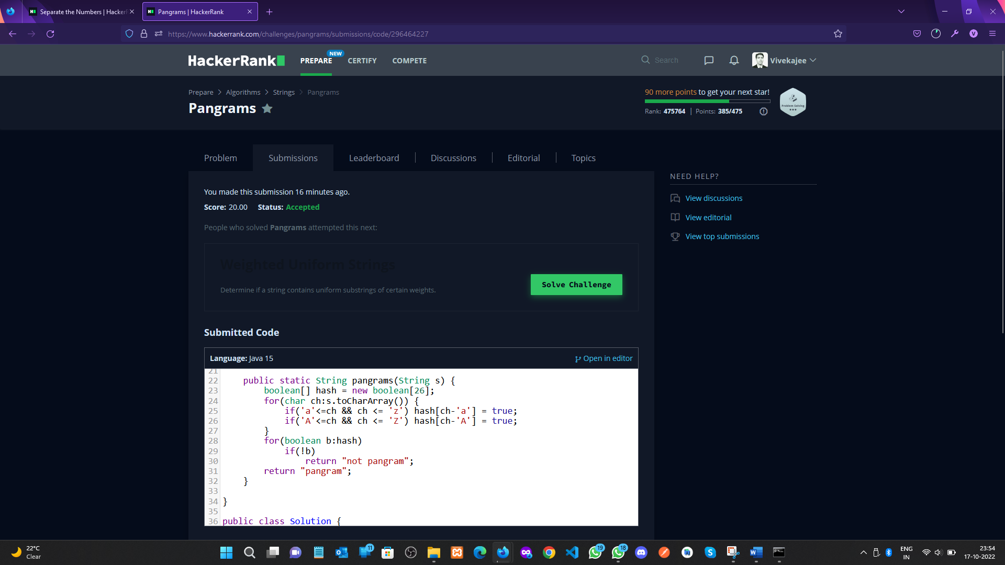 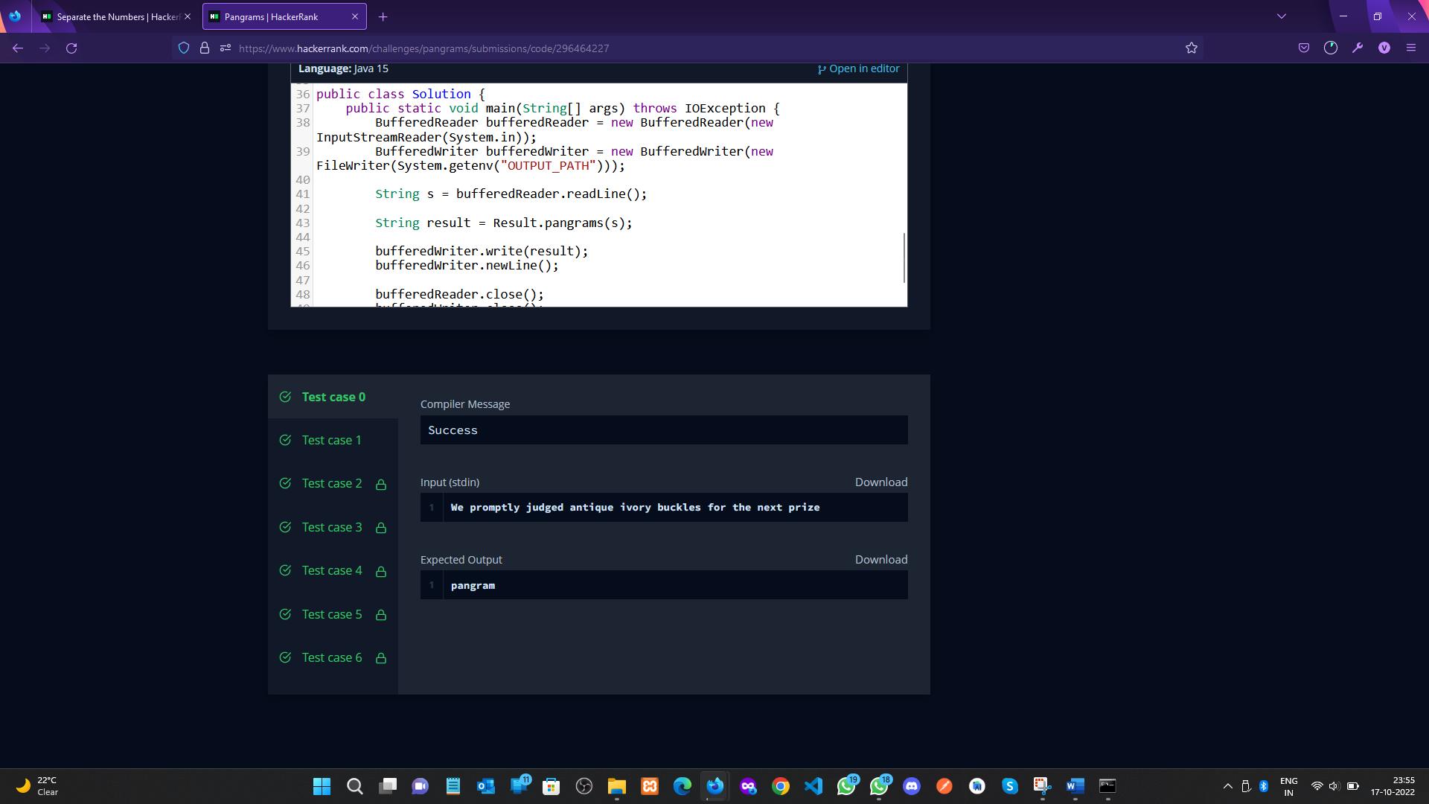

**Learning outcomes (What I have learnt):**

a. Learnt about String concept.

1. b. Learnt about Number separation concept from string.
2. c. Learn about the pangram concept.

**Evaluation Grid (To be created per the faculty's SOP and Assessment guidelines):**

|  |  |  |  |
| --- | --- | --- | --- |
| Sr. No. | Parameters | Marks Obtained | Maximum Marks |
| 1. | Worksheet completion including writing learning objectives/Outcomes.  (To be submitted at the end of the day). |  |  |
| 2. | Post-Lab Quiz Result. |  |  |
| 3. | Student Engagement in  Simulation/Demonstration/Performance and Controls/Pre-Lab Questions. |  |  |
|  | Signature of Faculty (with Date): | Total Marks Obtained: |  |